We have to say one more thing about matrices. They can be cut into blocks (which are smaller matrices). This often happens naturally. Here is a 4 by 6 matrix broken into blocks of size 2 by 2—and each block is just /:

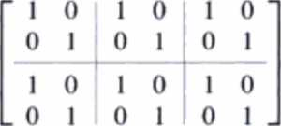

If B is also 4 by 6 and its block sizes match the block sizes in A, you can add A + B a block at a time.

We have seen block matrices before. The right side vector b was placed next to A in the ''augmented matrix.' Then [ A b ] has two blocks of different sizes. Multiplying by an elimination matrix gave [ EA Eb]. No problem to multiply blocks times blocks, when their shapes permit:

2G Block multiplication If the cuts between columns of A match the cuts between rows of B, then block multiplication of AB is allowed:



This equation is the same as if the blocks were numbers (which are 1 by 1 blocks). We are careful to keep A's in front of because BA can be different. The cuts between rows of A give cuts between rows of AB. Any column cuts in B are also column cuts in AB.

Main point When matrices split into blocks, it is often simpler to see how they act. The block matrix of I‘s above is much clearer than the original 4 by 6 matrix A.